Implementation of Infantry Squad Organization for Realistic Squad Battle Game

Nak Hyean Goo *, Dong Hoon Lee and Mi Jin Kim

Department of Visual Contents, Division of Digital Contents
Graudate School of Dongseo University, Dongseo University
Busan, South Korea
rnskrwl1@naver.com, dhl@dongseo.ac.kr, mjkim@dongseo.ac.kr

Abstract

In this paper, we analyze the composition and size of the squad used in the US Army textbooks to create a more realistic scene in battle scenes for a large scale troop, and implemented it as a game AI. The basic algorithm of the implementation is based on Reynold’s steering behavioral algorithm, constructing a squad Formation, utilizing a combination of basic behaviors such as searching and arriving. Therefore realistic squad composition and realistic movement result I was able to get.

Keywords : game AI, behavior algorithm

I. Introduction

The world's interest in AI is increasing day by day and its AI level is gradually rising. In the past, AI was an indispensable element of the game, and the early game AI caused passive and simple behavior depending solely on the player's behavior, such as hardware, graphics, and sound. However, AI began playing an increasingly important role in the game as the technological advances and people wanted to play more realistic and natural games.
This paper presents techniques for making realistic representation of the movements of the infantry used in combat in various games. Implementation of infantry should take into account the implementation of group actions of squad, platoon, and battalion units based on individual military independent behavioral models. The most basic infantry operations in combat are based on unit-level combat, and this paper also focuses on how to express realistic unit-level behavior.
A common technique used in existing games is to express this as a combination of individual actions based on Reynolds' traditional behavioral behavior (Steering Behavior) algorithm. However, battle scenes implemented without consideration of the actual squad's behavior have the problem of diminishing the reality. Therefore, the purpose of this paper is to express the large composition of attack team of 5 units and squad team of 11 units as a game artificial intelligence based on the data on formation of squad size used for actual infantry operation. The creation of these game AIs is worthy of study as a basis for more realistic squad combat simulations.
The composition of this paper is as follows. First, chapter 2 presents the analysis and considerations of the composition and basic structure used in the US Army textbooks. The detailed description of the implementation based on this and the experimental results are shown in Chapters 3 and 4, and finally the conclusions are given in Chapter 5.

II. Composition of squad formation

Basically, formation in units is used for the purpose of coordination with one platoon and other platoon on the ground, to deploy firepower to support direct firing, to minimize blind spots between squad members, and to facilitate combat . As a result, the commander must evaluate the situation and determine the optimal formation for the mission and situation.
To do this, all squadrons and soldiers must have their own basic positions, and soldiers must be able to see their leader at that location. Likewise, the leader must be able to see his soldiers. By doing this, the leader can use them to direct them. The formation provides a 360-degree field of view to anticipate contact with enemies on the sides or fronts, and to take advantage of enemy attacks. formation does not require precise alignment. Platoons and squads must maintain the flexibility to change to the size appropriate for their situation.
The US Army squad in the US Army manual (Figure 2) is a combination of two Fire teams from Figure 1 Therefore, in order to form the formation of a squad, the formation of two fire teams must be formed first in the squad.

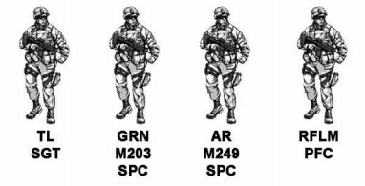
Fig.1 Composition of Fire team

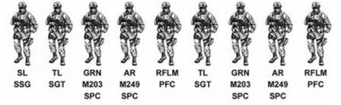
Fig.2 Composition of Squad.

Basically, the formation of a fire team consists of a fire team wedge and a fire team file. Fire team wedge (Figure 3) is a basic form of the Fire team, which gives team members control and flexibility. It is also capable of immediate shooting in all directions and has excellent security because the view is distributed in all directions. Depending on the terrain, the wedge can expand or contract. However, it is difficult to control when the field of view is limited or narrow.

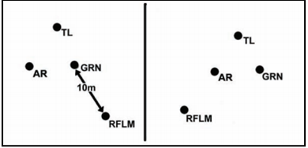
Fig.3 Fire team Wedge.

The Fire team file (Figure 4) is used to pass through restricted fields or terrain. Team members are very easy to control, but flexibility is lower than Fire team wedge. Instant fire on the sides is possible, but front and rear are limited and security is very low.

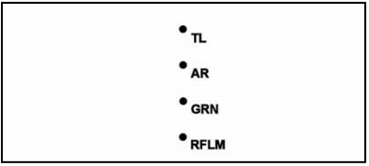
Fig.4 Fire team file

The formation of the US military squad is a combination of two fire teams. There are three types of Squad column, Squad line, and Squad file.
The Squad column (Figure 5) is also flexible because it is good for controlling squad members and advantageous for tactical behavior with the basic formation of the squad. It has a wide fire range for the sides, but it is limited for the front. Security is excellent because the view is distributed in all directions. Rough terrain, poor visibility, or other factors, you can also modify the Squad column to an easy-to-control Squad file. If the terrain becomes rougher or easier to control on the way, the soldiers return to their original formation again.

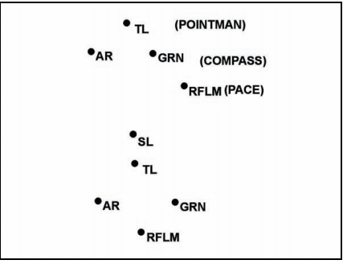
Fig.5 Squad Column.
Squad Line (Figure 6) is used when maximum firepower is required for forward. As a result, the controllability is not as good as the squad column and the tactical behavior is limited, so the flexibility is not good. Security for front is good, but side and rear are vulnerable. It is used in assault because it provides maximum firepower for the front.

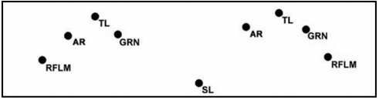
Fig.6 Squad Line

The Squad File (Figure 7) is used to pass through limited visibility or terrain. It is very easy to control, but is less flexible because it is very difficult to do tactical actions. Immediate shooting on the sides is possible, but the front and rear are limited. Security is very low. When you meet an enemy, it is not optimal formation, but it gives the leader maximum control. Leaders can be positioned forward or backward, and if they are located in front, they can raise squad's morale and make important decisions instantly. If you are located in the rear, you may be provided additional control over the formation rear.

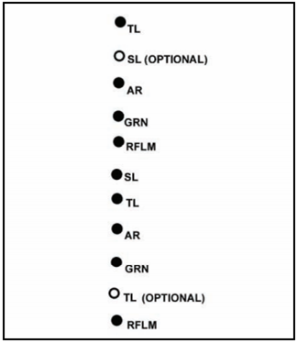
Fig.7 Squad File

III. System configuration and implementation for formation implementation

Based on the above mentioned data, Unity 3D was used to implement it. First, implement fire team1 and fire team2. Fire teams are under the control of their respective team leaders and can make formation changes through them.(Figure 8, Figure 9) The way a team leader communicates commands to team members implements an event-responsive communication structure. In general, there are two methods for communicating using blackboard architecture and telegraph system.
Among them, it is known that the method using the telegraph system is excellent in terms of implementation and performance in a small scale system. In this paper, we implemented communication between team members based on the telegraph system implemented by Buckland [6].
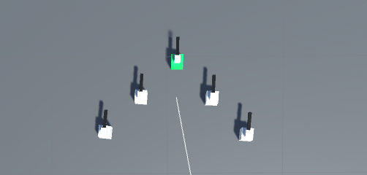
Fig.8 Implemented team leader1, fire team1 and Fire team wedge.

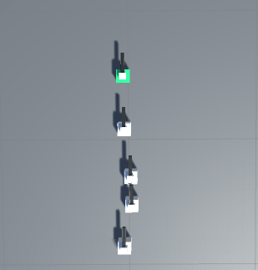
Fig.9 Implemented team leader2, fire team2, and fire team file.

Then build a squad on top of the fire team, and join fire team1 and fire team2 that you built before. After that, we create a Squad leader for control the squad and make decisions. Then the team leaders, who are under the control of the squad leader are change the formation of a fire team that matches the current squad formation.
Figures 10, 11, and 12 are examples of three basic formation that can be taken in a squad. A squad member may take a designated formation under the direction of the team leader and the squad leader.

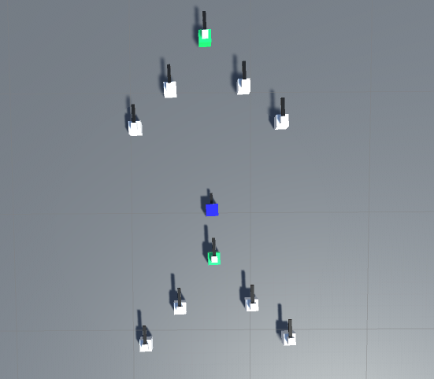
Fig.10 Iimplemented.squad of Squad column

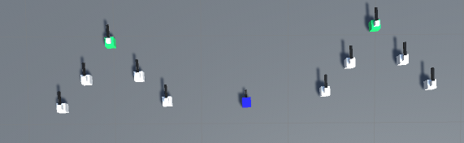
Fig.11 Implemented.squad of Squad Line

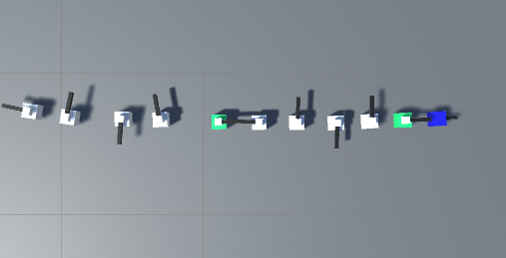
Fig.12 Implemented squad of Squad File.

IV. Result

The prototype for the experiment constituted the test scene for the experiment which changed the basic squad formation appropriately according to the situation and when the experimenter moved the squad, we naturally wanted to check the formation change of the squad that fit the situation.
For example, in one situation. If a squad leader enters a Jungle-like terrain with limited and difficulty of visibility while maintaining squad columns squad leader judge the situation and change formation into squad file specialized for backwoods movement. The team leaders then change his formation of fire team into a fire team file at the correct location in accordance with the squad leaderd's judgment (Figures 13 and 14).

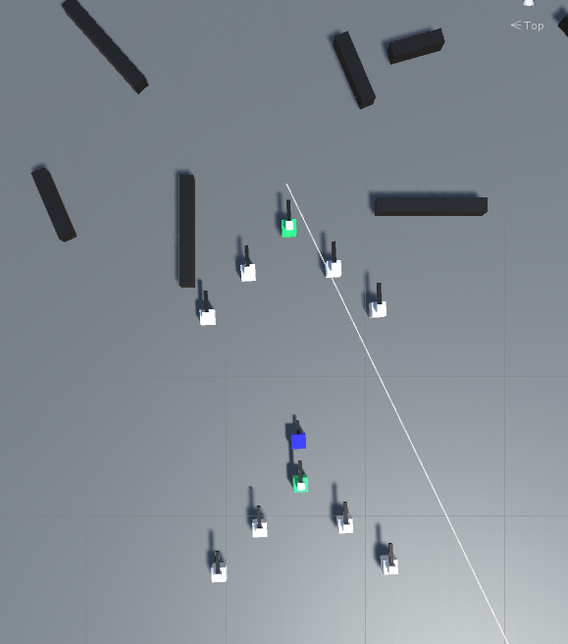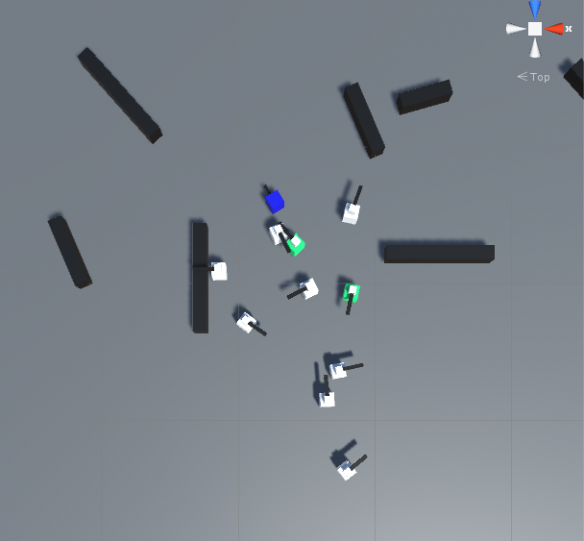
Fig 13 Change Squad column to Squad file.

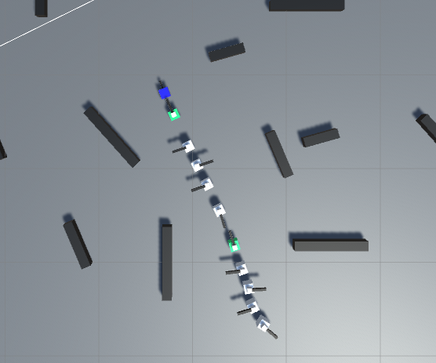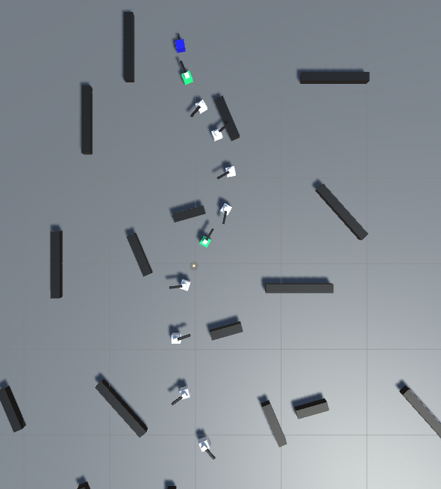
Fig 14 change to Squad file and break through the backwoods

V. Conclusion

In this paper, we propose a formation configuration of a squad as a basic unit for realistic squad combat. Based on the Fire team and squad configuration presented in the US Army manuals, we implemented five tactical configurations, and we were able to confirm the changes of squad formation according to the situation of the squad leader.
At present, research has been conducted to confirm only the changes of the five tactical formation according to the most basic situation.
In the future, we plan to develop a various formation configuration and a platoon unit combat system by combining the decision structure of the unit commander and the five basic tactical units in various situations.

References

[1]HEADQUARTERS DEPARTMENT OF THE ARMY, “FM 3-21.8(FM 7-8)The Infantry Rifle Platoon and Squad”, pp3-1 - 3-19, Washington, DC, 28 March 2007.
- Steve Rabin, "AI game programming wisdom4", pp61 - 81, CharlesRiverMedia, 2008.
- Adam Lake, “Game Programming Gems 8”, pp371 - 382, Wow Books, 2011.
- Hyeonju lee, “Game Artificial Intelligence Technology”, pp103 - 109, Analysis of Trends in Telecommunications, 2005.
- Steve Rabin, "Game AI PRO" pp169 - 183, CRC, 2013.
- Mat Buckland, "Programming Game AI by Example" pp74 - 91, Wordware Publishing, 2004

